SARDAR VALLABHBHAI NATIONAL INSTITUTE OF TECHNOLOGY, SURAT

ASSIGNMENT ON IMPLIMENTATION AND LIMITATIONS OF ALTERNATE DIRECTION IMPLICIT METHOD FOR TEMPORAL VARIATION.

(UNDER THE GUIDANCE OF DR. JYOTRIMAY BANERJEE)

BY:
MAYANK AGRAWAL (U15ME025)
GAURAV PHALKE (U15ME026)
SHREYAS NERKAR(U15ME030)
ANEIL RAY(U15ME041)



TABLE OF CONTENTS

Serial No. | Topics
1. | Problem Statement.
2. | Governing Equations.
3. | Discretization techniques for grid and differential equations.
4. | Algebraic Equations for different boundary conditions using Alternate Direction Implicit Method.
5. | Matlab Code.
6. | Results and discussion.
  1. | Grid Independence Test.
  2. | Code Validation.
  3. | Variation with respect to Thermal Diffusivity.
  4. | Instability in implementing Alternate Direction Implicit Method.
  5. | Implementation for the given boundary conditions.

5. Matlab Code:
tic
clc
clear all

INPUT
L=input('Enter the length of the plate in meter:\n');
B=input('Enter the breadth of the plate in meter:\n');
m=input('no. of divisions in x direction\n');
n=input('no. of divisions in y direction\n');
fprintf ('Enter\n 1 for dirichlet condition(Constant Temp)\n 2 for homogenous neumann condition(Insulated)\n 3 for Robins condition (Convective)\n 4 for Heterogeneous Neunman Condition (constant heat flux)\n');
N=input('Enter the choice for the North wall\n');
S=input('Enter the choice for the South wall\n');
W=input('Enter the choice for the West wall\n');
E=input('Enter the choice for the East wall\n');
k=input('Enter the conductivity of the material\n');
Tin=input('Enter initial temperature for the body in (C)\n');
alpha=input('Enter the value of thermal diffusivity\n'); t1=input('Enter the value of time in sec at which the temperature is to be evaluated\n');
dx=L/m;
dy=B/n;

BOUNDARY IDENTIFICATION
switch N
case 1
Tn=input('Enter the temperature at North Wall\n');
case 3
Tconvn=input('Enter the Temperature of the Convective Media at North Wall\n');
h=input('Enter the convective coefficient for the North Wall\n');
hn=h/k;
case 4
qn=input('Enter The value of heat flux \n');
end
switch S
case 1
Ts=input('Enter the temperature at South Wall\n');
case 3
Tconvs=input('Enter the Temperature of the Convective Media at South Wall\n');
h=input('Enter the h coefficient for the South Wall\n');
hs=h/k;
case 4
qs=input('Enter the value of heat flux at South Wall\n');
end
switch E
case 1
Te=input('Enter the temperature at East Wall\n');
case 3
Tconve=input('Enter the Temperature of the Convective Media at East Wall\n');
h=input('Enter the h for the East Wall\n');
he=h/k;
case 4
qe=input('Enter the value of heat flux at East Wall\n');
end
switch W
case 1
Tw=input('Enter the temperature at West Wall\n');
case 3
Tconvw=input('Enter the Temperature of the Convective Media at West Wall\n');
h=input('Enter the h for the West Wall\n');
hw=h/k;
case 4
qw=input('Enter the value of heat flux at West Wall\n');
end

time step declaration
dt=input('Enter the step increase in time in secs\n');
while dt>=(dx^2/(alpha));
fprintf('\n the value of step increase in time is not valid. Enter a value less than ')
condition=dx^2/alpha
dt=input('Enter the correct step increase in time in secs\n');
end
ap=(1+alpha*dt/dx^2);
aw=-(alpha*dt/(2*dx^2));
ae=aw;
as=aw;
an=as;
ap0=(1-alpha*dt/dx^2);
Told(1:n,1:m)=Tin;
itr=0;
for T=0:dt:t1

Rows
for I=1:1:n
DR(1:n+1,1:m+1)=0;
for j=1:1:m %%TDMA MATRIX GENERATION
DR(j,j)=ap;
DR(j,j+1)=ae;
DR(j+1,j)=aw;
if I==1
switch S
case 1
BR(j)=ap0*Told(I,j)-an*Told(I+1,j)-as*(2*Ts-Told(I,j));
case 2
BR(j)=(ap0-as)*Told(I,j)-an*Told(I+1,j);
case 3
BR(j)=ap0*Told(I,j)-an*Told(I+1,j)-as*((2*hs*dx*Tconvs+Told(I,j)*(2-hs*dx))/(hs*dx+2));
case 4
BR(j)=ap0*Told(I,j)-an*Told(I+1,j)-as*(Told(I,j)+qs/k);
end
elseif I==n
switch N
case 1
BR(j)=ap0*Told(I,j)-an*(2*Tn-Told(I,j))-as*Told(I-1,j);
case 2
BR(j)=(ap0-an)*Told(I,j)-as*Told(I-1,j);
case 3
BR(j)=ap0*Told(I,j)-an*((2*Tconvn*hn*dx+Told(I,j)*(2-hn*dx))/(2+hn*dx))-as*Told(I-1,j);
case 4
BR(j)=ap0*Told(I,j)-an*(Told(I,j)-qn/k)-as*Told(I-1,j);
end
else
BR(j)=ap0*Told(I,j)-an*Told(I+1,j)-as*Told(I-1,j);
end
end
switch W
case 1
DR(1,1)=ap-aw;
BR(1)=BR(1)-2*Tw*aw;
case 2
DR(1,1)=ap+aw;
BR(1)=BR(1);
case 3
DR(1,1)=ap-aw*((2-hw*dx)/(2+hw*dx));
BR(1)=BR(1)-aw*2*hw*dx*Tconvw/(2+dx*hw);
case 4
DR(1,1)=ap+aw;
BR(1)=BR(1)-aw*qw/k;
end
switch E
case 1
DR(m,m)=ap-ae;
BR(m)=BR(m)-2*Te*ae;
case 2
DR(m,m)=ap+ae;
BR(m)=BR(m);
case 3
DR(m,m)=ap+ae*((2-he*dx)/(2+he*dx));
BR(m)=BR(m)-2*ae*Tconve*dx*he/(2+he*dx);
case 4
DR(m,m)=ap+ae;
BR(m)=BR(m)+ae*qe/k;
end
for j=2:1:m %%TDMA MATRIX OPERATION
DR(j,j)=DR(j,j)*DR(j-1,j-1)/DR(j,j-1)-DR(j-1,j);
if j<m
DR(j,j+1)=DR(j,j+1)*DR(j-1,j-1)/DR(j,j-1);
end
BR(j)=BR(j)*DR(j-1,j-1)/DR(j,j-1)-BR(j-1);
end
Tnew(I,m)=BR(j)/DR(j,j);
for j=m-1:-1:1
Tnew(I,j)=(BR(j)-Tnew(I,j+1)*DR(j,j+1))/DR(j,j); %%% TDMA SOLUTION
end
end
Told1=Tnew;

Columns
for J=1:1:m
DC(1:n+1,1:m+1)=0;
for i=1:1:n %%%TDMA MATRIX GENERATION
DC(i,i)=ap;
DC(i,i+1)=ae;
DC(i+1,i)=aw;
if J==1
switch W
case 1
BC(i)=ap0*Told1(i,J)-ae*Told1(i,J+1)-aw*(2*Tw-Told1(i,J));
case 2
BC(i)=(ap0-aw)*Told1(i,J)-ae*Told1(i,J+1);
case 3
BC(i)=ap0*Told1(i,J)-ae*Told1(i,J+1)-aw*(Tconvw*2*dx*hw+Told1(i,J)*(2-hw*dx))/(2+hw*dx);
case 4
BC(i)=ap0*Told1(i,J)-ae*Told1(i,J+1)-aw*(Told1(i,J)+qw/k);
end
elseif J==m
switch E
case 1
BC(i)=ap0*Told1(i,J)-ae*(2*Te-Told1(i,J))-aw*Told1(i,J-1);
case 2
BC(i)=(ap0-ae)*Told1(i,J)-aw*Told1(i,J-1);
case 3
BC(i)=ap0*Told1(i,J)-ae*(Tconve*2*dx*he+Told1(i,J)*(2-he*dx))/(2+he*dx)-aw*Told1(i,J-1);
case 4
BC(i)=ap0*Told1(i,J)-ae*(Told1(i,J)-qe/k)-aw*Told1(i,J-1);
end
else
BC(i)=ap0*Told1(i,J)-ae*Told1(i,J+1)-aw*Told1(i,J-1);
end
end
switch S
case 1
DC(1,1)=ap-as;
BC(1)=BC(1)-2*Ts*as;
case 2
DC(1,1)=ap+as;
BC(1)=BC(1);
case 3
DC(1,1)=ap-as*(2-hs*dx)/(2+hs*dx);
BC(1)=BC(1)-2*as*Tconvs*hs*dx/(2+hs*dx);
case 4
DC(1,1)=ap+as;
BC(1)=BC(1)-as*qs/k;
end
switch N
case 1
DC(n,n)=ap-an;
BC(n)=BC(n)-2*Tn*an;
case 2
DC(n,n)=ap+an;
BC(n)=BC(n);
case 3
DC(n,n)=ap-an*(2-hn*dx)/(2+hn*dx);
BC(n)=BC(n)-2*an*Tconvn*hn*dx/(2+hn*dx);
case 4
DC(n,n)=ap+an;
BC(n)=BC(n)+an*qn/k;
end
for i=2:1:n %%TDMA MATRIX OPERATION
DC(i,i)=DC(i,i)*DC(i-1,i-1)/DC(i,i-1)-DC(i-1,i);
if i<n
DC(i,i+1)=DC(i,i+1)*DC(i-1,i-1)/DC(i,i-1)-DC(i-1,i+1);
end
BC(i)=BC(i)*DC(i-1,i-1)/DC(i,i-1)-BC(i-1);
end
Tnew(i,J)=BC(i)/DC(i,i);
for i=n-1:-1:1
Tnew(i,J)=(BC(i)-Tnew(i+1,J)*DC(i,i+1))/DC(i,i); %TDMA SOLUTION
end
end
err=Tnew-Told;
if max(abs(err))<1e-5
break;
end
Told=Tnew;
if mod(T,(dt*100))==0
plot(Tnew)%plotting
end
hold on
itr=itr+1
end
X=dx:dx:1;
toc0

6. Results and Discussions:
- Grid Independent Test:

Fig 1. Plot of steady state temperature Vs length of the plate for grid size of 5, 10, 20, 40, 80.

From the above graph, the steady state temperature for the grid size 40 (Red) and the grid size 80 (Blue) almost overlap each other. Thus we have chosen grid size of 40 for our further calculations. The conditions stated for the above results are as follows:
- Temperature at all the faces = 1
- Initial Body Temperature = 0
- Thermal Diffusivity = 1
- The step increase in time dt = 0.0001

- Code Validation:
Steady State Temperature value for the condition initial =0 and boundary conditions- constant temperature at 1. The thermal diffusivity is 1 and the increment in time is 0.0004 secs. Fig 2 (a) (U) From code. Fig 2 (b) (D) From ansys.
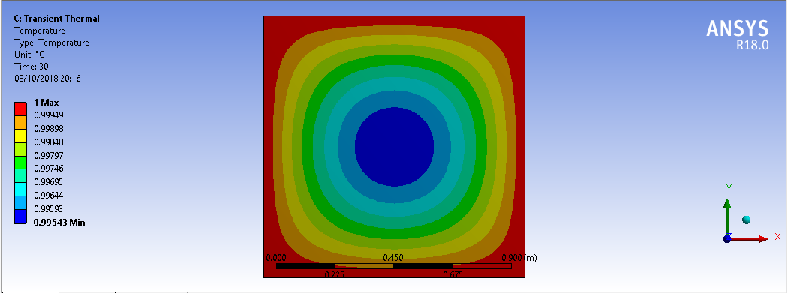
Fig 3. Temporal Variation of the Temperature for the above stated condition.
The results of Fig.2 (a) and Fig 2 (b) are comparable and hence the code is validated for the given conditions. The majority horizontal sections in the variation in the Fig 3. Are due to the initial temperature, wherein the heat has just started to diffuse and thus the temperature is varied near the boundaries but not in the central cells.
- Variation w.r.t Thermal Diffusivity:
Fig 4. Graph of Temperature vs Length expressed in terms of grid size. The variation of temperature w.r.t thermal conductivity at
time t=0.5 seconds after initial condition of T=0 pertaining to the Dirichlet boundary condition of temperature being ‘1’ on all the faces.

The graph shows the diffusion of the heat throughout the plate for different values of the thermal conductivity. As we can infer from the graph as the thermal conductivity increases, the heat flows faster into the system. The above statement is qualified as the Temperature of the plate starts to reach the value corresponding to the boundary value (i.e. 1) faster.

- Instability in implementing Alternate Direction Implicit Method:

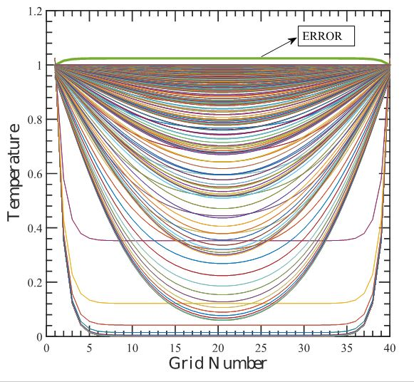
Fig 5. (L) The graph is plotted for the same boundary conditions as above with dt=0.0004. Fig 6 (R) The graph is plotted for the same boundary conditions as above with dt=0.001

In the second graph (fig 6), the green coloured contour shoots over the boundary value, when there are no other source terms (heat generation, advection, input flux, etc). This result is unrealistic as the temperature of the body cannot go over the temperature of the boundary if it is initially at a lower value than that of the boundary. This violates the physics. The results are for the following condition:
- Temperature at all the faces = 1
- Initial Body Temperature = 0
- Thermal Diffusivity = 1
- The step increase in time dt = 0.0001
- Grid size 40*40

In the first graph (fig 5), the contours are plotted for the same conditions as above. The results shown are different with the former explanation. The reason for that is the instability caused due to the increase in the time step. As the time step value increases above 0.000625 seconds, the contribution from the p^{th} cell from the previous time step becomes negative.
; As this value turns negative, the physics is violated.
Thus the instability of the alternate direction implicit method can be inferred from the above two graphs.

- Implementation for the given boundary condition:
Fig 7. Temporal variation of the Temperature for the boundary conditions as specified in the discretization process.

Fig 8. The heatmap for the boundary conditions as specified in the discretization process.

Fig 9. The contour plot for the given boundary conditions as specified in the Discretization process.

As can be seen from the contour plot, the contours are perpendicular to the top surface (South wall with Insulated boundary) and are at constant slope at the bottom side (North Wall with constant heat flux). The initial conditions have been defined and thus the code has run without any errors.

